Backlog Items:

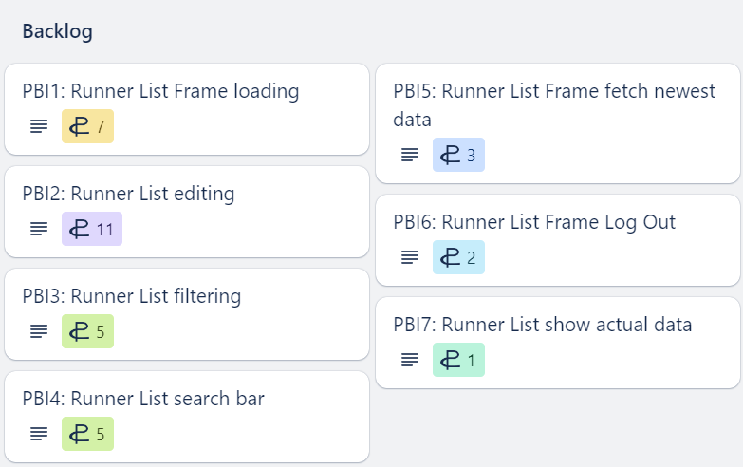

PBI1

PBI2

PBI3

PBI4

PBI5

PBI6

PBI7

